Canadian Pony Breeders Hall of Fame
Perpetual trophy donated by The Equestrian Pit Ltd. in memory of Karin Von Herff

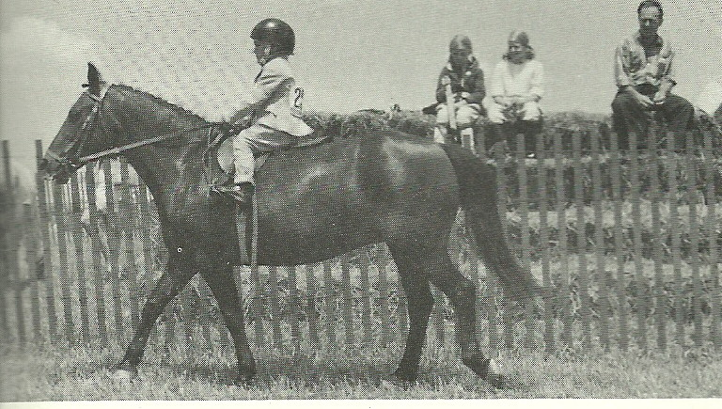
1992 - Minnie Mouse
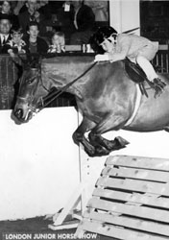

12.1 brown mare
Foaled 1960. Purchased in 1964 by Delphoine Kirton from Dick Day for Kim Kirton. In the late 60s they made their showring debut. The pair could be seen sharing lunch as well as many Pony Jumper and Pony Hunter Awards and Championships. When Kim outgrew Minnie, she was passed on to Stephanie Kirton, the Mitchell family children and Jennifer Neumeister.
1969 Zone Champion Small Pony Jumper
1970 Zone Pony Champion for Small Pony Hunter and Pony Jumper
1971 Zone Champion Small Pony Working Hunter and Pony Jumper
1972 Zone Champion Small Pony (not stated but presume Hunter and Jumper)
1992 inducted into Pony Breeders Hall of Fame
She was 32 at the time of her induction and spent her last days babysitting youngstock.
Survived 2 barn fires, countless horse shows.
Died at age 36, the night of Big Ben’s retirement ceremony at the RAWF. Buried at Kimarlin Farm (Kim Kirton).

1991 - Findeln Picnic
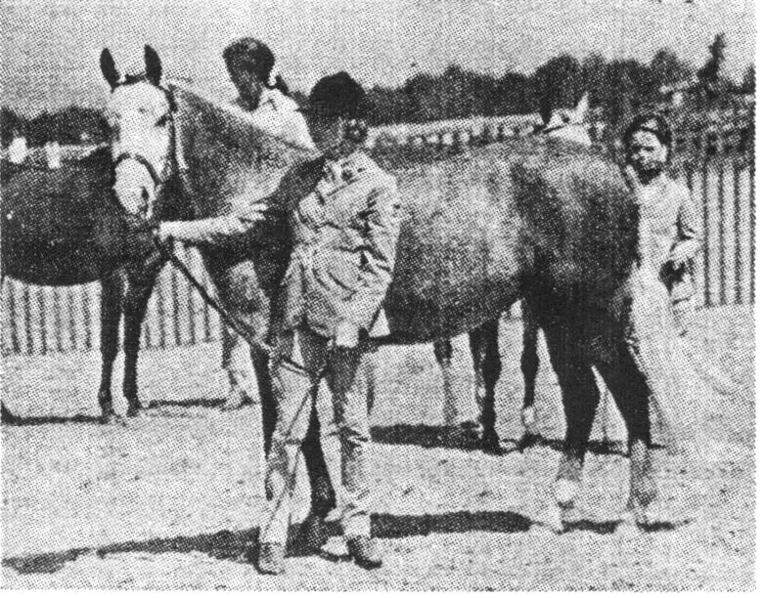
1966 – 2001 grey Welsh B mare (Brockwell Spider X Black’s Duchess)
Breeder: Nancy G (Benitz) Bedford, Fox Run Farm, Kettleby, ON
Owner: Michael Sifton
Picnic was broke, trained and shown as a green pony for Nancy Bedford. Heather and Michael Sifton purchased Picnic for their sons Michael and Derek. Michael hunted her for several seasons and Derek started his riding life in the leadline class at the Canadian Pony Breeders Show. When the boys were too tall Picnic joined the Tynedale Farm ponies and was invaluable teaching young riders.
As well as the lessons, Picnic competed successfully in shows and was one of the leading mounts on the Tynedale Pony Club Prince Philip Games and D Rally teams.
After many years of service Sarah Brown acquired Picnic and from 1984 to 1988 she competed in Pony Club games, D Rallies and Tetrathalon. She was Pony Club Reserve Stadium Jumping Champion in 1985 at the ripe old age of 19. She also hunter, showed at Canadian Pony Breeders, Hunter Trials and pony shows. She even tried her hooves at Trail riding in the Vivian Forest.
The younger Brown sisters, Melissa and Emily, also learned to ride on Picnic. She retired in the countryside overlooking Lake Simcoe enjoying quiet hacks until her death.

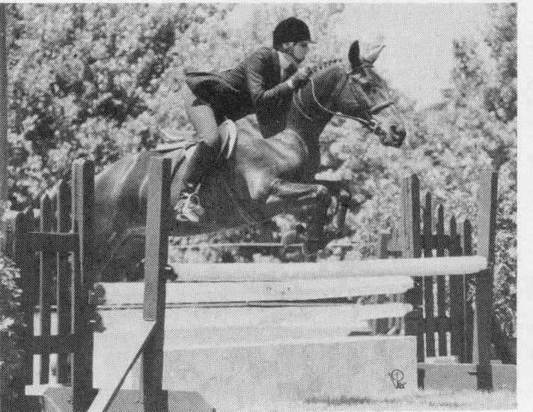
1990 – J Alexander II
Throughout his 25 years, his career has spanned all aspects of riding – Pleasure, A Circuit, Pony Club, PPG and ultimately Riding for the Disabled.
JJ is a Quarter Horse cross, dark bay in colour, distinguished by a rather round body requiring a perpetual diet.
His life can be divided into three distinct sections.
Purchased by Sue Pritchard for a client, he spent his early years at Robin Hill Stables, when his jumping abilities were discovered after he cleared a 4’ paddock fence from a standstill. During those years he had 3 owners but many riders. His honesty and manners made him the perfect pony to introduce youngster to competition, both Pony Jumper and Hunter Divisions.
Unhappily children grow and the pony didn’t so in 1978 he had another family – the Ameli Family.
These years were the most lucrative for JJ. Having 3 young riders in the family he spent 7 years successfully competing in the A Circuit Large Pony Division and Equitation accruing hundreds of ribbons in Schooling and Recognized Shows. He took these riders to Championship levels and ultimately to the Royal Winter Fair on 3 occasions.
He climaxed his Hunter Career with a 2nd at the Royal in 1985.
Sadly outgrown, he had another career change. JJ was loaned to a young rider and over the next 3 years participated in Dressage and Eventing and Pony Club events.
At 23 years of age, he was jumping without refusal the cross-country courses. He was part of the successful PPG team that made it to the PPG Finals.
In 1989, JJ came to CARD where his manners make him an ideal pony for teaching young physical and mentally disabled children the art of horsemanship.
JJ does not enjoy inactivity and puts in his share of the work required by these remarkable horses but the rewards of carrots, apples and all the petting are worth it. He now jumps for fun.

1989 - *Cilrhedyn Betty
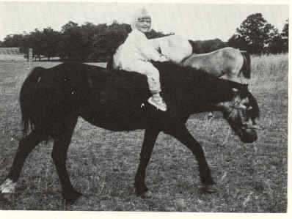
1955 – 1990 dark brown imported Welsh A mare (Ceulan Revelry X *Cilrhedyn Twinkle)
Breeder: WG Williams
Owner: Adele Rockwell
Cilrhedyn Betty depicts the true old-fashioned Welsh pony – hardy, durable, kind and sensible. At 34 years of age, her teeth may be worn but there is no sagging in her back.
Betty’s contribution to ponies in North America has been profound, not just in numbers but carrying on the Welsh qualities she illustrates.
After several years as a broodmare for her importers, the Rockwells of Ardmore Stud, she was sold to Mrs. Rousom as a broodmare for her “Rosshire” hunter ponies. One year , Betty was sent to winter with Bill Porter at his Hunter Breeding Station in Durham. It seems his grandchildren decided on their own to have some fun with the pony. They found some harness, put her to the cutter and drove off down the road complete with bells. Porter described her as the perfect child’s pony. He knew not what an understatement this was…Betty had never been broken to either ride or drive.
Betty was always good with children. In her later years she served Laurie Iverson’s grandchildren and Ellen McInroy’s thoroughbred filly as a baby sitter. She is retired now at Ardmore Stub, still respected by the younger mares but looked after by one of her great granddaughters.
From Betty are descended 32 stallions standing at stud from Maine to California and Nova Scotia to British Columbia. These and their descendants have won (at a conservative estimate), well over 1000 championships – Welsh Pony Society of America High Score Championship, Canadian High Score Championships, American Horse Show Association High Score Championships and CEF Provincial Awards besides many, many championships at shows like the Royal Winter Fair, Devon Horse Show and year after year, the Canadian Pony Breeders Show. 1988 Best of Breed Section A Champion, Best of Breed Section B Champion, Supreme Champion All Breeds and the Small-Medium Pleasure Champion and Pleasure Driving Champion. SOME MOM!
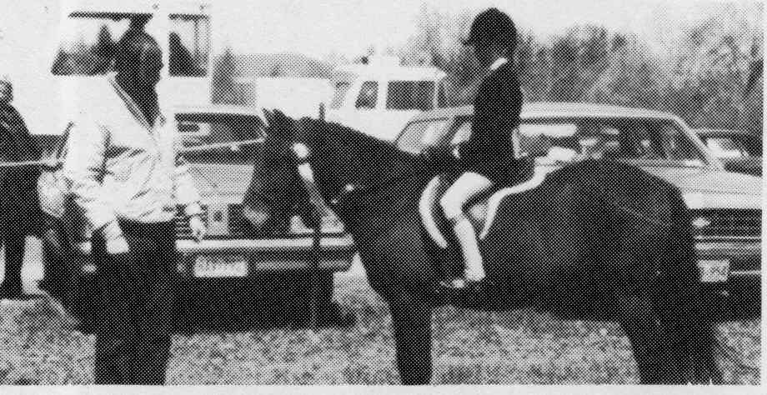
1988 - Bobby Shaftoe
Bobby Shaftoe’s first recorded owner was Trish Oswald, who bought the 4 year old pony stallion from well-known Quebec dealer, Fred Townsend, in 1966 for the princely sum of $150.
The 12.2 stallion was pretty bumptious, so Trish – brought up in the North of England – named him after the lively character in the Northumbrian folk song, “Bobby Shaftoe”
Some months later, Penny Thomas’ eldest daughter, then aged 8, took a great liking to the now-gelded Bobby and since Trish’s 6-year old son had developed a rapport with one of Penny’s ponies (another $150 “Freddy Special” called Firefly) a swap was made. Firefly, now 28, is also still going strong.
Bobby was ridden by all of Penny’s 5 children, to countless successes in the show ring. He also worked hard in Penny’s riding school, teaching legions of children to ride and giving their first heady taste of victory in leadline and walk/trot classes. However, Bobby never limited himself to mere hunter classes – despite his numerous Provincial Championships and good ribbons at the Royal. He’s been a wonderful Pony |club friend – going cross county like the wind, and helping his Branch, Vaudriel County to many Rally team successes, winning pony jumper classes, hunting, scoring 7’s and 8’s in Dressage and showng all the other ponies how to play Prince Philip Cup Games.
When Penny retired from the riding school game, she sold Bobby to Elissa Dallegret, who had a wonderful time with him. From Elissa, he went on to pupils of Robbie MacInture, in Williamstown ON and has now joined the Fiddler’s Green gang with Pam and Joe Nuth in Stittsville ON, where he continues in his versatility way.
….Some return on an investment of a hundred and fifty dollars!
The Prince Philip Cup Games riders at the 1987 |Royal Winter Fair selected Bobby Shaftoe as the “Most Useful All-Round Pony”!

1987 - Tynedale Ponies
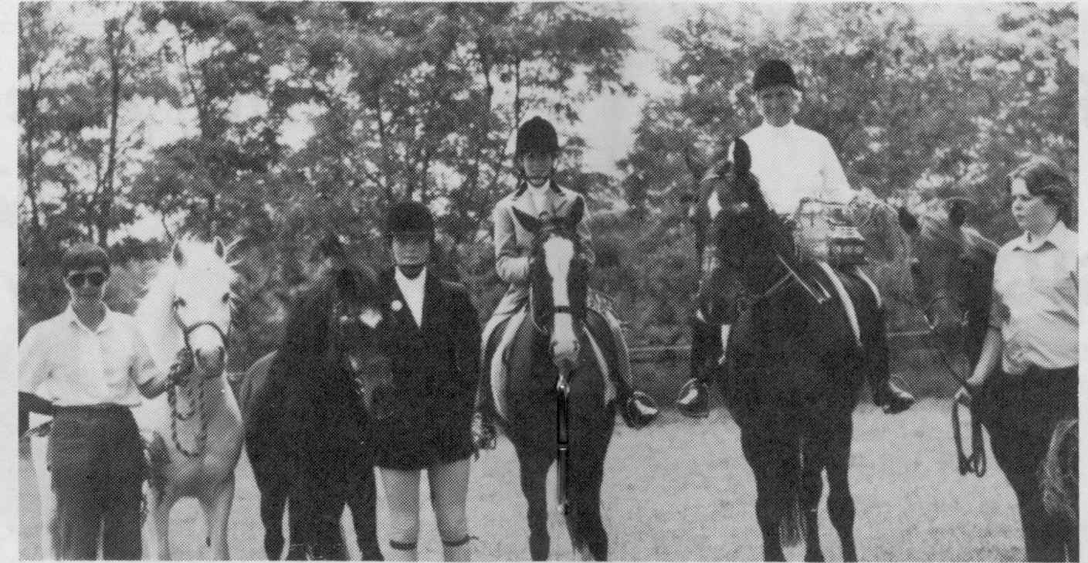

1986 - Silver Duchess

1985 - Ardmore Fleetwing
1961 – 1996 grey Welsh A stallion (*Coed Coch Sulgwyn X *Gretton Butterfly)
Breeder/Owner: Adele Rockwell
Sire of 6 registered ponies

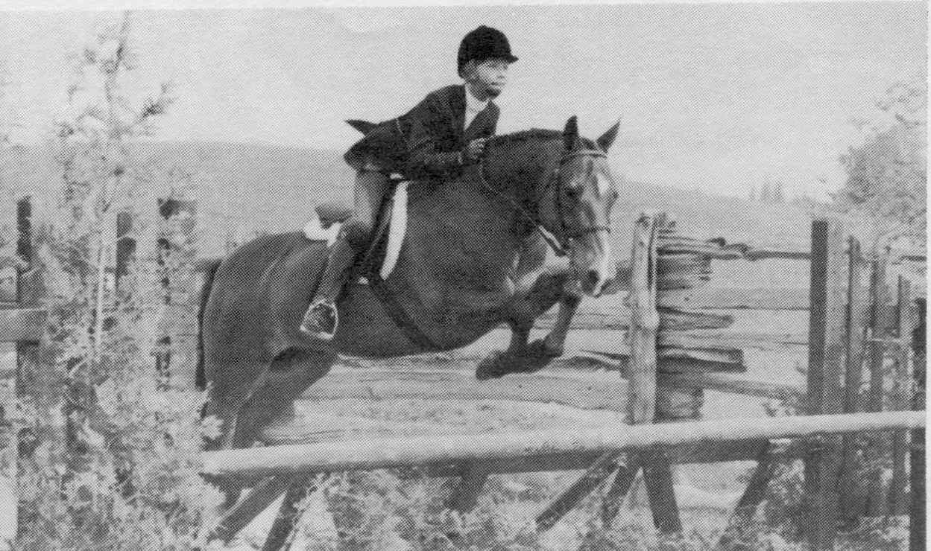
1984 - Merrie Mite
Registered as Forest Hill Merriemite
1964 bay (roan?) New Forest gelding (*Mudeford Streak X *Merrie Mitzina)
Breeder/Owner: Dr. & Mrs. JG Holbrook, Ancaster ON
In 1967, MerrieMite was sent to Mr & Mrs Gordon Carpenter for their daughter to break. Shawn (Carpenter) Hayes broke him and got him ready to show. He was then sold to Cathy (Collard) Roy who started his show career and campaigned him for four years. Numerous ribbons and championships were won by this combination including ribbons at the Royal Winter Fair and Reserve Zone Large Pony Conformation Hunter in 1970.
His next owner was Ann McIntyre, who did very well showing him and again won numerous ribbons.
He was then purchased by Reber Ridge Stables, owned by Bobbie and Len Reber. They used him to get children started in the showring. Both Jennifer O’Neill and Jenifer Smith started their show careers on him and both have gone on to be Zone Champions.
Now retired at Reber Ridge and runs free on the farm. When you approach from the road, that’s not a loose pony you see – just MerrieMite – who has jumped yet another fence in order to dine out on the front lawn.

1983 - Jiminy Cricket
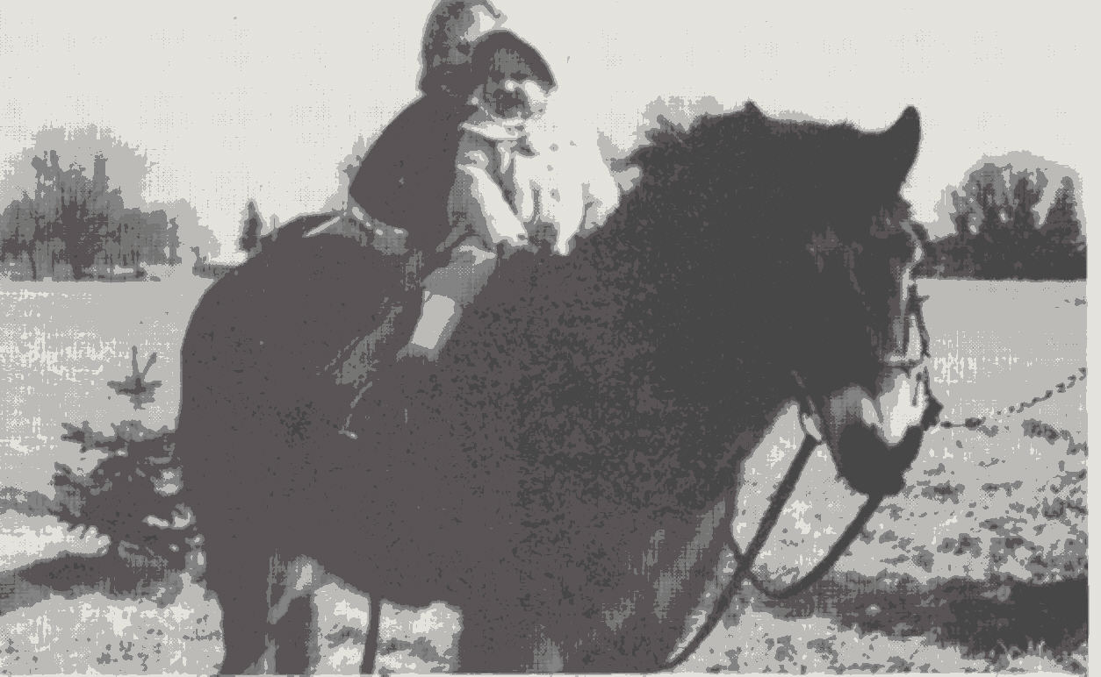
1958 bay Exmoor gelding
Breeder: Ian Macdonald, Brussels ON
Out of British imports
The Summers family bought him as a 2 year old for their daughter Betsy who broke and pony clubbed him at Timbertop Pony Club. With Betsy aboard, although both were still young they surprised everybody with their successes at various pony club rallies, etc.
From the Summers, he moved to British Columbia with Mrs. Churchill Mann and family. Here he started his true teaching career. Later he returned home to Ontario to find himself back at Jokers Hill. He then moved on to Lou Mikucki, Ambercroft Stables where he was a much treasured school pony. Upon the closing of Lou’s riding school, Jiminy was purchased by Peter and Taddy Harris for their daughter Meg. Meg enjoyed many good years with Jiminy in the showring as well as pony clubbing and fox hunting with Toronto & North York Hunt Club.
In 1978, Jiminy was passed on to Eddie and Irene Bayer for their daughter Raphaela who enjoyed 3 years of fun with him.
Jiminy now resides at Blue Star Farm in Mount Albert. Although semi-retired he is “starting off” Evie and Bill Frisque’s son Graeme and is a sitter for their broodmares. It is hoped that in a year or two he will introduce Evan Frisque to the pony workd too.
Althought a known escape artists and a real character, Jiminy has been many a child’s best friend.

1982 - *Cwmowen Sunray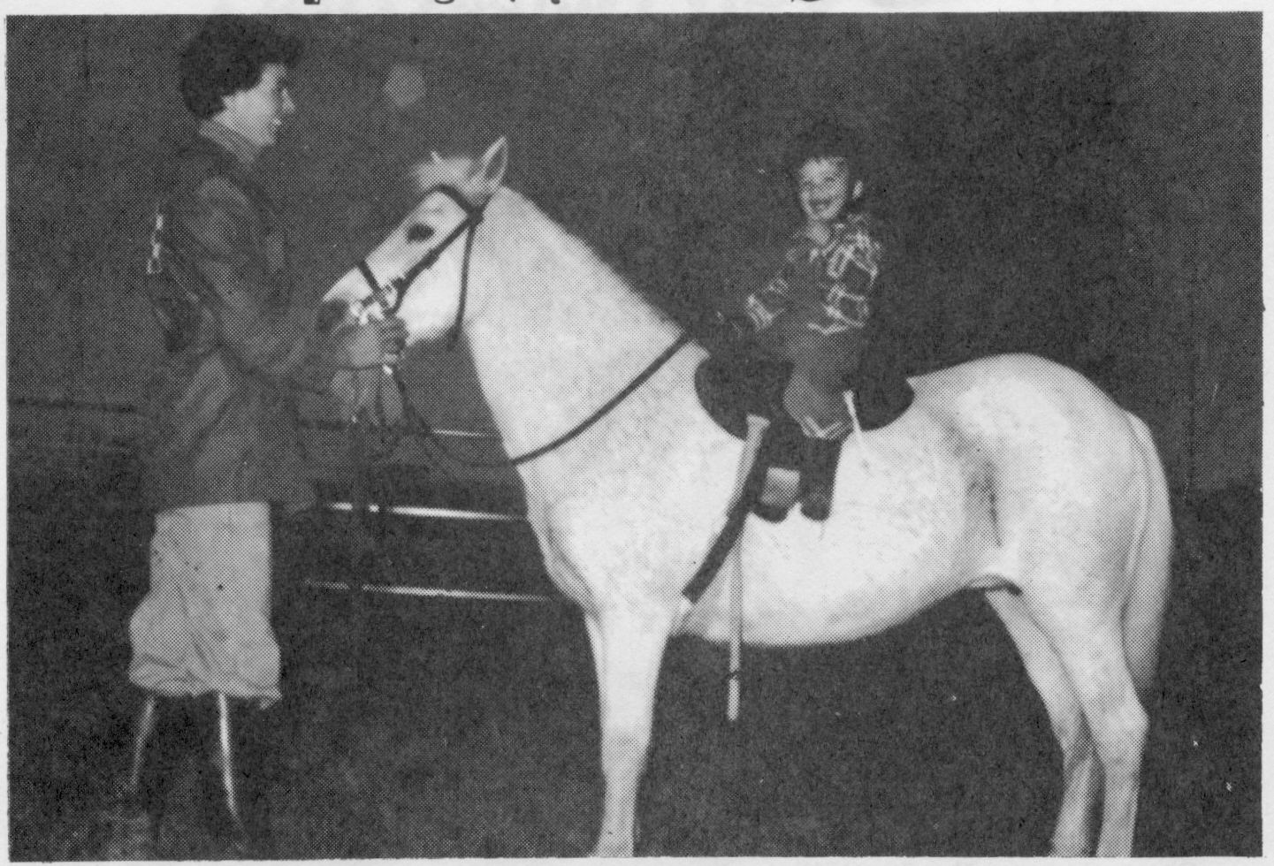
1953 – 1988 grey imported Welsh A mare (Cwm Cream Dandy X Cwmowen Sunshine)
Breeder: Glythin Jones, Wales
Owner: Adele Rockwell
Typical of the kind, stout hearted Welsh Mountain Pony breed so influential in the improvement of Canadian children’s ponies
Wild and unhandled out of the Mountains she was imported to Canada in 1957. Sunray started off the children from at least 3 separate families, being leadline pony for Penny Murray’s boy Kieren, to Laurie Iverson’s grand children and later the Lalonde family in Caledon. A number of Sunray’s 13 foals were extremely successful in winning championships for their respective owners. Amongst the winners, Ardmore Radiant ridden by Sheila McPherson, now on Canada’s International Jumping Team, also Ardmore Array, an early mount for another Canadian Team Rider, Kim Kirton.
Sunray earned her place in the Pony Hall of Fame for her influence towards instilling a love for ponies and some of her foals have started many children on the way to being Canada’s horse men and women of the present and the future.

1981 – Snowflake (aka Piccolo)
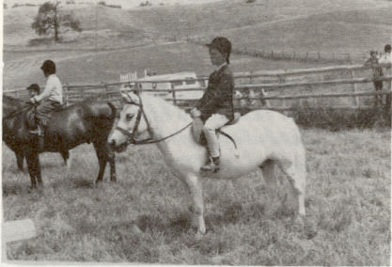
1957 – Grey (grey skewbald/pinto) 11 hand
Scots Grey Cinders X
Breeder: Jack Cusack, 3C Pony Ranch
Originally named Crackers, he was spotted at the CNE tied to a wheel going round and round. JP Chassels fell in love with this thin little pony. Although he was a favourite of all the kids, his owner was persuaded to part with him in time for JP’s Christmas present. In 1964. JP showed Piccolo at the very first Pony Breeders Show in 1965, where he won 3rd place. Piccolo was hunted very successfully with Toronto & North York Hunt Club for 3-4 seasons, then started endurance riding and finished as Ontario Junior Endurance Ride Champion in 1969.
Piccolo also distinguished himself by starring as a “Parade Horse” at the opening of the new Human Society Animal Shelter in Aurora ON, going quietly and fearlessly as was his custom. Piccolo was loaned to the late Col. And Mrs. Jim Strathy for their grandson for 2 years or more and then on to Jim and Marianne Elder for daughter Erin. Erin re-christened him “Snowflake”, showed him and won more ribbons as well as hunter with T & NY. From there he went to Margo and Moffat Dunlap’s son John and when John outgrew him Snowflake went on to Rose and Greg Carpenter’s daughter Dara. His final home was with the family of Janet and Ian Black being ridden by daughter Sarah.
Whenever, if ever – no one wants Piccolo – he will always be welcome to luxurious retirement in Uxbridge.

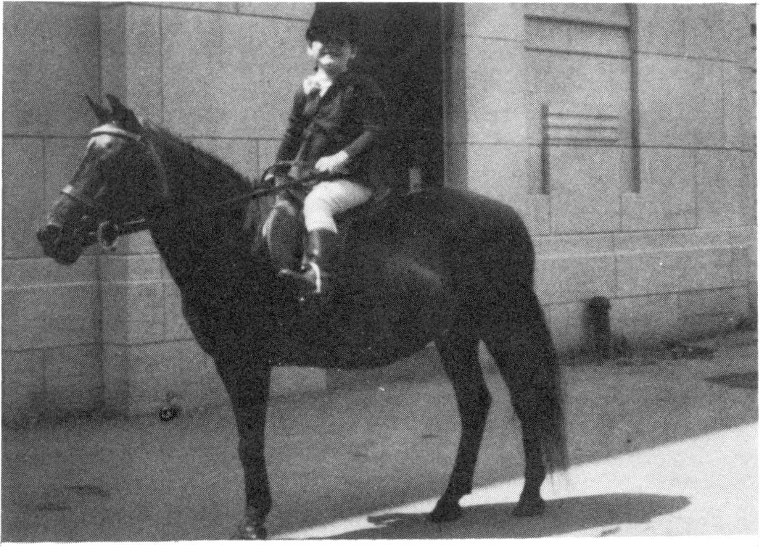
1980 – Pet (aka April Silhouette)
11.3 black Welsh cross mare
Owner: Russel & Darlene Morton, Morton Welsh Show Stables, \Sutton ON
Acquired by Russel’s father in 1966 at a farm auction. Used by the Morton family as a child’s pleasure saddle pony. Pet was then sold to Darlene’s sister for her 3 year old daughter in 1969. Later sold to Darlene’s mother as a pet and finally given to the 2 Morton boys for their own first pony.
Pet had been shown very lightly in the late 70s, in child’s lead-line, costume and pleasure driving pony. She was driven only once a year and that was at the CNE where Pet never placed lower than 4th.In 1978, a bad virus went through the barn at the CNE and Pet became ill, she didn’t recover from that illness. Her attending vet surmised her age at over 35.
Pet never bit, kicked, threw or ran away with anyone. Any child could groom or ride her and very was very quiet, friendly and patient even when Raymond practiced clipped when he was 4 and no one was watching them. Ray cut off half her tail half way down . Pet was never a champion, nor did she catch an adult’s eye as a specimen of equine beauty but she was a beautiful champion to the two boys that owned her.

1979 - Goldie

1978 - Banjo

1977 - Bo Peep
Possibly imported pony GBR10455/GBR8775

1976 - Scots Grey Captain
~14hh black with blanket unregistered POA stallion
Owner: Jack Cusack
Competed pony jumper with Jill Barton

1975 - Ming Toy

